Hong Kong Exchanges and Clearing Limited and The Stock Exchange of Hong Kong Limited take no responsibility for the contents of this announcement, make no representation as to its accuracy or completeness and expressly disclaim any liability whatsoever for any loss howsoever arising from or in reliance upon the whole or any part of the contents of this announcement.

This announcement is for information purposes only and does not constitute an invitation or offer to acquire, purchase or subscribe for securities of the Company.
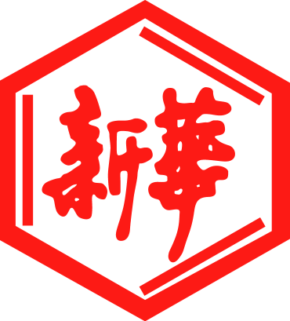

山東新華製藥股份有限公司

Shandong Xinhua Pharmaceutical Company Limited

(a joint stock company established in the People’s Republic of China with limited liability)

(Stock Code: 00719)

APPOINTMENT OF INDEPENDENT FINANCIAL ADVISER

Reference is made to the announcement of Shandong Xinhua Pharmaceutical Company Limited (the “Company”) dated 14 April 2021 in relation to, inter alia, (i) the Proposed A Shares Issue; (ii) the connected transaction in relation to the proposed subscription of A Shares by Hualu Investment; and (iii) the application for the Whitewash Waiver. Unless otherwise stated, capitalised terms used in this announcement shall have the same meanings as defined in the said announcement dated 14 April 2021.

APPOINTMENT OF INDEPENDENT FINANCIAL ADVISER

The Board is pleased to announce that Octal Capital Limited (“Octal Capital”), a corporation licensed to carry out Type 1 (dealing in securities) and Type 6 (advising on corporate finance) regulated activities under the Securities and Futures Ordinance (Chapter 571 of the Laws of Hong Kong), has been appointed as the Independent Financial Adviser to advise the Listing Rules Independent Board Committee, the Code Independent Board Committee and the Independent Shareholders in relation to the Proposed A Shares Issue and the Whitewash Waiver. The appointment of Octal Capital as the Independent Financial Adviser has been approved by the Code Independent Board Committee pursuant to Rule 2.1 of the Takeovers Code.

The letter of advice from Octal Capital in relation to the Proposed A Shares Issue and Whitewash Waiver will be included in the circular to be despatched to the Shareholders in due course.

The completion of the Proposed A Shares Issue is subject to the satisfaction of certain conditions, including but not limited to, the grant of the Whitewash Waiver by the Executive, which may or may not be granted by the Executive. The granting of the Whitewash Waiver is a non-waivable condition precedent to the A Shares Subscription Agreement. Accordingly, the Proposed A Shares Issue may or may not proceed. Shareholders and potential investors are advised to exercise caution when dealing in the Shares.

By Order of the Board
Shandong Xinhua Pharmaceutical Company Limited
Zhang Daiming
Chairman

19 April 2021, Zibo, PRC

As at the date of this announcement, the Board comprises:

Executive Directors:  Mr. Zhang Daiming (Chairman)  Mr. Du Deping  Mr. He Tongqing | Independent Non-executive Directors:  Mr. Pan Guangcheng  Mr. Zhu Jianwei  Mr. Lo Wah Wai
Non-executive Directors:
Mr. Cong Kechun
Mr. Xu Lie

The directors of the Company jointly and severally accept full responsibility for the accuracy of the information contained in this announcement, and confirm, having made all reasonable enquiries, that to the best of their knowledge, opinions expressed in this announcement have been arrived at after due and careful consideration and there are no other facts not contained in this announcement the omission of which would make any statements in this announcement misleading.

